Experiment-8
Understand cost drivers using the COCOMO site for team projects
(02/04/2026)

Understanding cost drivers in the Constructive Cost Model (COCOMO) allows project managers to refine software effort estimates by considering 15-17 factors—such as team capability, product complexity, and tool usage—rather than relying solely on lines of code. For team projects, these drivers directly calculate an Effort Adjustment Factor (EAF) that can increase or decrease the final project cost based on environmental and personnel attributes.

Key COCOMO Cost Drivers for Team Projects (Intermediate/II)
Cost drivers are rated from "Very Low" to "Extra High," acting as multipliers (EAF) on the base effort equation.
- Personnel Attributes (Highest Impact):
  - ACAP (Analyst Capability): Team experience in problem-solving.
  - PCAP (Programmer Capability): Skill level and efficiency of developers.
  - AEXP & VEXP: Application and Virtual Machine (environment) experience.
  - LEXP: Language and tool experience.
- Product Attributes:
  - RELY: Required software reliability (e.g., high for safety-critical systems).
  - CPLX: Product complexity (algorithms, data management).
- Project Attributes:
  - TOOL: Use of software tools (CASE tools, debuggers).
  - MODP: Use of modern programming practices.
  - SCED: Required development schedule (compressed schedules increase cost).
- Platform Attributes:
  - TIME/STOR: Execution time and memory constraints.

Steps for Installation/Setup of COCOMO Tools
While COCOMO can be calculated manually, web-based tools and applications allow for rapid simulation. A commonly referenced tool for COCOMO II is SystemStar or various online COCOMO calculators.
- Locate a Tool: Search for a "COCOMO II Calculator" or download a COCOMO estimation tool (e.g., Softstar Systems' SystemStar).
- Download and Install: If using a desktop application, download the installation package (e.g., .exe or .zip) and run the setup wizard following the on-screen instructions.
- Setup Initial Project Parameters:
  - Define the Project Name.
  - Estimate the Size in KSLOC (Kilo Source Lines of Code) or use Function Points.
  - Select the development mode: Organic (Small, simple), Semi-Detached (Medium), or Embedded (Complex, strict).
- Configure Cost Drivers (The Assessment Step):
  - Open the "Cost Drivers" or "Effort Multipliers" section.
  - Rate the 15+ drivers (e.g., set PCAP to "High" if the team is experienced).
  - The tool will calculate the EAF (Effort Adjustment Factor) automatically.
- Compute Estimation: Run the calculator to generate Effort (Person-Months), Duration (Months), and Staffing requirements.

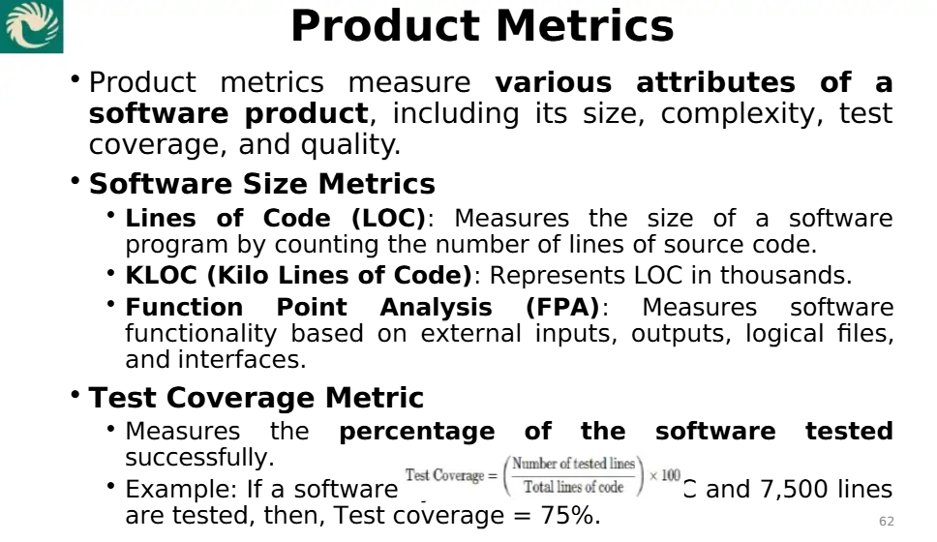
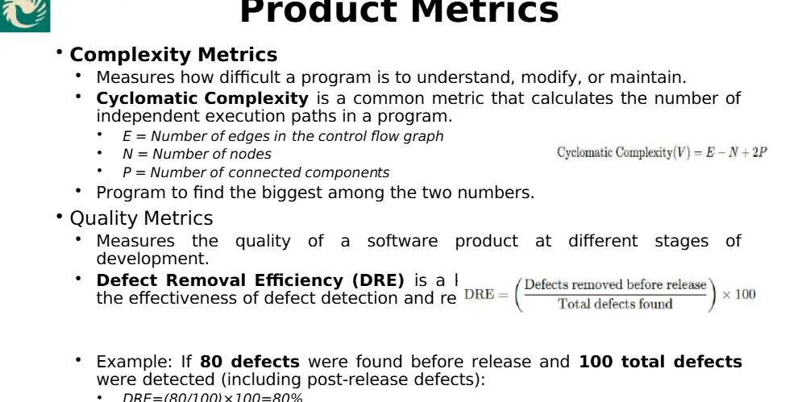

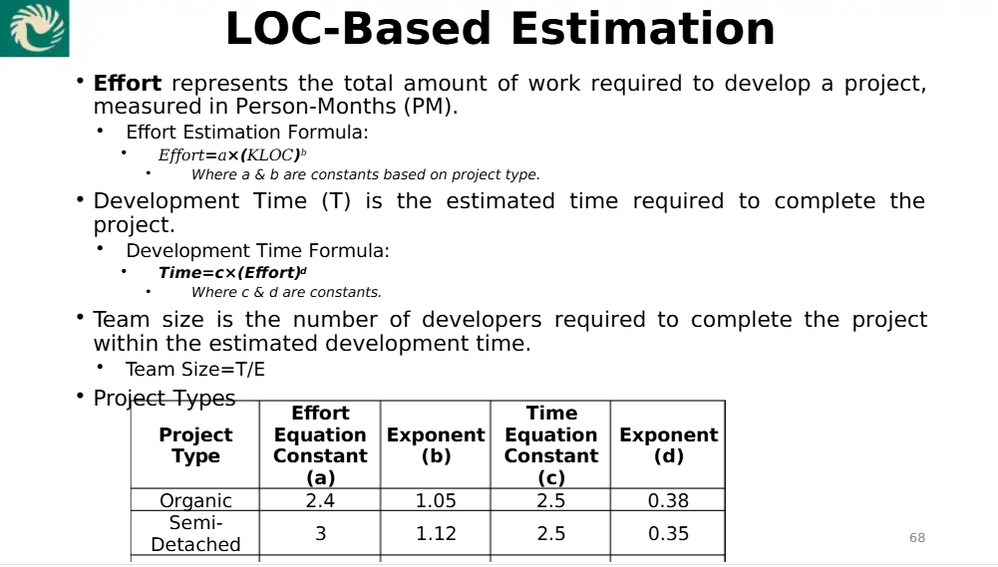

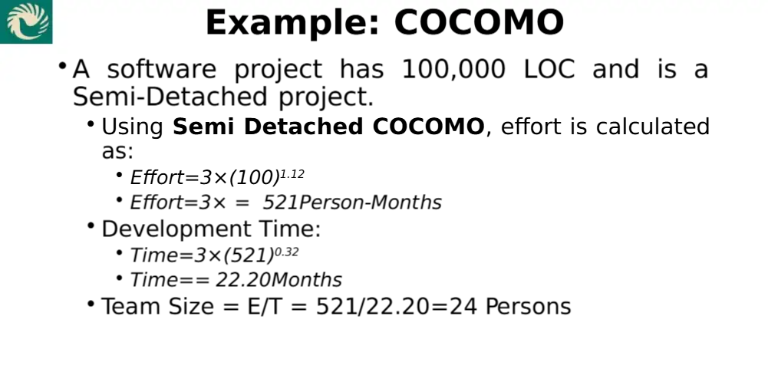
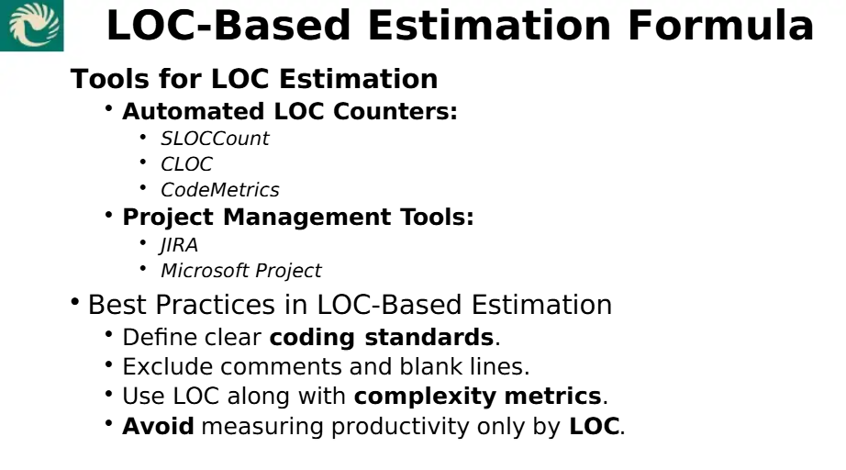
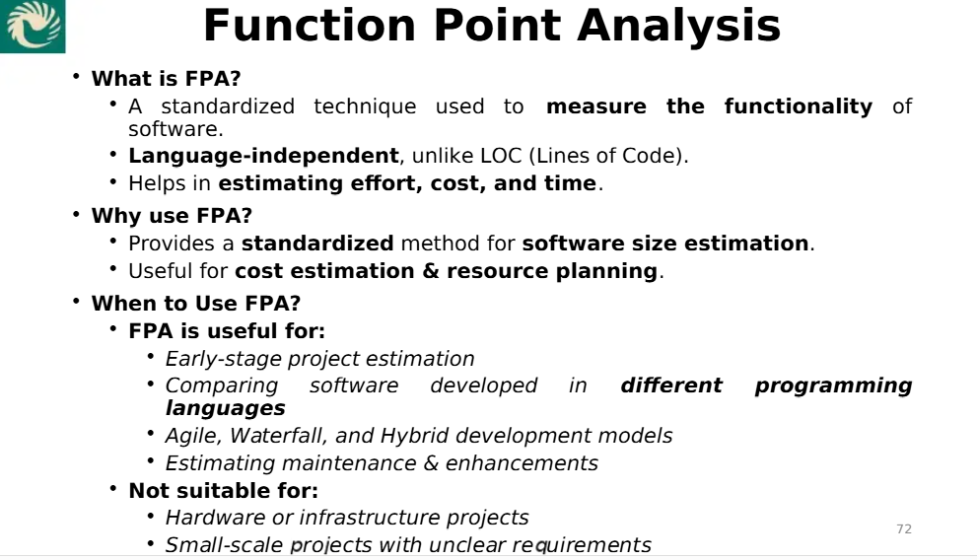
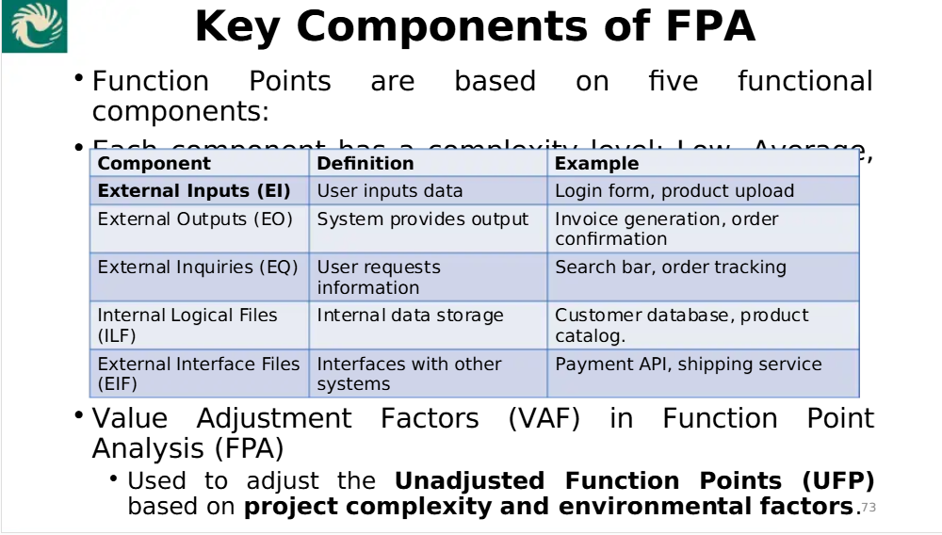
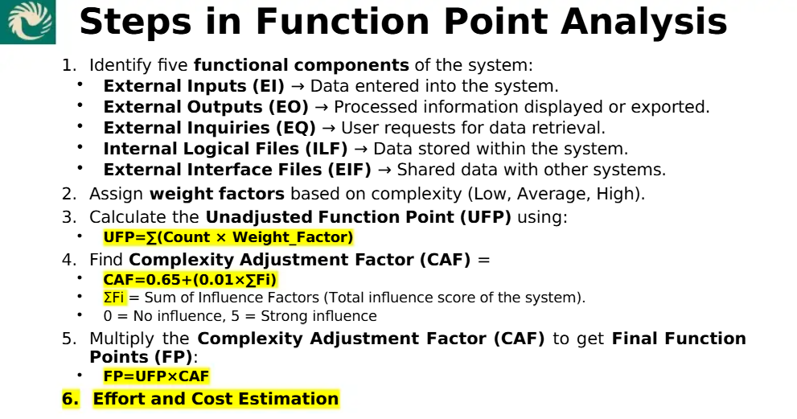
Function Point (FP) is an element of software development which helps to approximate the cost of development early in the process. It may measures functionality from user's point of view.
Example 1 :-
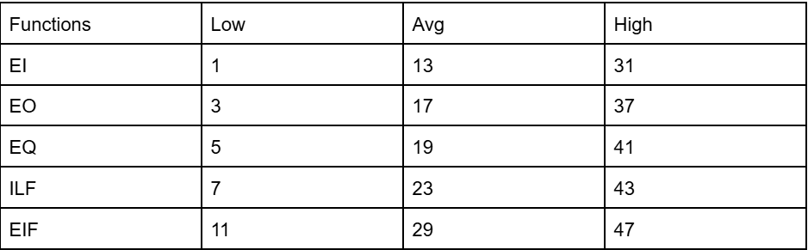

Step-by-Step Calculation:
- Step-1: Calculate F
Since all Complexity Adjustment Factors are average, scale = 3
- F = 14 × scale
F = 14 × 3 = 42
- Step-2: Calculate Complexity Adjustment Factor (CAF)
- CAF = 0.65 + (0.01 × F)
CAF = 0.65 + (0.01 × 42) = 0.65 + 0.42 = 1.07
- Step-3: Calculate Unadjusted Function Point (UFP)
Using Average weighting factors from the table:
- EI (External Inputs) → 50 × 13
- EO (External Outputs) → 40 × 17
- EQ (External Inquiries) → 35 × 19
- ILF (Internal Logical Files) → 6 × 23
- EIF (External Interface Files) → 4 × 29
Calculation:
UFP = (50 × 13) + (40 × 17) + (35 × 19) + (6 × 23) + (4 × 29)
Let’s compute each term:
- 50 × 13 = 650
- 40 × 17 = 680
- 35 × 19 = 665
- 6 × 23 = 138
- 4 × 29 = 116
- Now sum them up:
- 650 + 680 = 1330
- 1330 + 665 = 1995
- 1995 + 138 = 2133
2133 + 116 = 2249
So, UFP = 2249
- Step-4: Calculate Final Function Point (FP)
- FP = UFP × CAF
FP = 2249 × 1.07
- Final Calculation:
2249 × 1.07 = 2406.43

Final Answer:
Function Point (FP) = 2406.43
Example 2 :-
Consider a software project with the following information domain characteristic for the calculation of function point metric.
Number of external inputs (I) = 101
FP = UFPVAF
2 Number of external output (O) = 103
3 Number of external inquiries (E) = 107
4 Number of files (F) = 109
SNumber of external interfaces (N) = 113
It is given that the complexity weighting factors for I, O, E, F, and N are 1, 3, 5, 7, and 11, respectively. It is also given that, out of fourteen value adjustment factors that influence the development effort, four factors are not applicable, each of the other four factors has value 3, and each of the remaining factors has value 13. The computed value of the function point metric is
Solution:-

1. Calculate Unadjusted Function Points (UFP):
UFP = Σ(Number of Components × Complexity Weight)
- External Inputs (I): 101 × 1 = 101
- External Outputs (O): 103 × 3 = 309
- External Inquiries (E): 107 × 5 = 535
- Files (F): 109 × 7 = 763
- External Interfaces (N): 113 × 11 = 1243
UFP = 101 + 309 + 535 + 763 + 1243 = 2951

2. Compute Complexity Adjustment Factor (CAF):
- Total 14 factors
- 4 factors are not applicable → 4 × 0 = 0
- 4 factors have a value of 3 → 4 × 3 = 12
- Remaining factors = 14 - 4 - 4 = 6 factors have a value of 13 → 6 × 13 = 78
Σ(Complexity Adjustment Factor) = 0 + 12 + 78 = 90
CAF = 0.65 + (0.01 × 90) = 0.65 + 0.90 = 1.55

3. Compute Function Point (FP):
FP = UFP × CAF = 2951 × 1.55 = 4574.05
The computed value of the function point metric is 4574.05 (or 4574 when rounded to the nearest whole number, as is common in such calculations).

